Define Complex Vector Voltage:
v_{abcs} = v_{as} + a v_{bs} + a² v_{cs} Space Vector

Define Complex Vector Current:
i_{abcs} = i_{as} + a i_{bs} + a² i_{cs}

3φ Machine:
v_{abcs} = v_{as} + a v_{bs} + a² v_{cs} i_{abcs} = i_{as} + a i_{bs} + a² i_{cs}

1) Stator Resistive Terms
i_{as} r_{s} + a i_{bs} r_{s} + a² i_{cs} r_{s} =

2) Stator Self Inductance Terms
(L_{ms} + L_{ls}) p (i_{as} + a i_{bs} + a² i_{cs}) =

L_{ms} p(λ_{as}) from bs and cs currents
3) Mutual Terms (Stator)

L_{ms} p =

L_{ms} p =
-a²
-1
-a

L_{ms} p =

4) Mutual Terms (Rotor)

L_{ms} p

= L_{ms} p

= p
0
= p

=

Stator Voltage Equation:

v_{abcs} = r_{s} i_{abcs} + +

L_{s}

Apply Turns Ratio

i = i _{abcr} r = ²r_{r} L_{m} = L_{ms}

v = v _{abcr} L = ²L_{mr} + L

The final complex vector equations with turns ratio transformations:

v_{abcs} = r_{s} i_{abcs} + L_{s} p i_{abcs} + L_{m} p

v = r i + L p i + L_{m} p

Rotation to a General Reference Frame
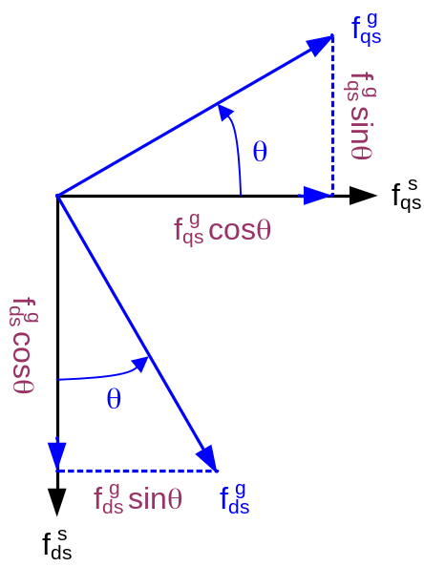
f = fcosθ + f sinθ

f = fcosθ - f sinθ

f = f – j f

= f cosθ + f sinθ – j f cosθ + j f sinθ

= f (cosθ + j sinθ) + f (sinθ – j cosθ)

= f (cosθ + j sinθ) – j f (cosθ + j sinθ)

= (f – j f) (cosθ + j sinθ)

→

Recall:
f f is a variable (v,i,λ)
x is where the variable comes from (r,s)
(actual location of variables)
y is where variables are referred to (r,s,g)

Stator Refered Complex Variable Equations (θ,ω = 0):

v = r_{s} i + L_{s} p i + L_{m} p i

v = r_{r} i + L_{r} p i + L_{m} p i - jω_{r} (L_{r} i + L_{m} i)
= r_{r} i + L_{r} (p - jω_{r}) i + L_{m} (p - jω_{r}) i

which can be re-written as:
v = r_{s} i + p l

v = r_{r} i + (p - jω_{r}) l

where
l = L_{s} i + L_{m} i

l = L_{r} i + L_{m} i

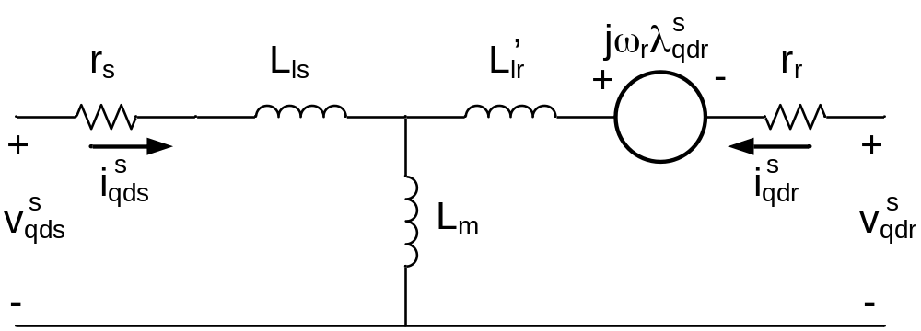
Complex, Stator Referred Model
Stator Referred, Complex Variable Equations:
v = (r_{s} + L_{s} p)i + L_{m} p i

v = [r_{r} + L_{r} (p - jω_{r})]i + L_{m} (p - jω_{r}) i

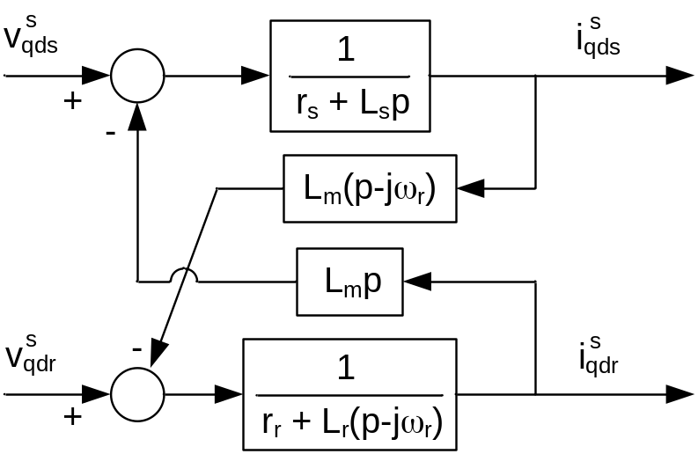
Complex, Stator Referred Block Diagram
For a squirrel cage induction motor, v = 0

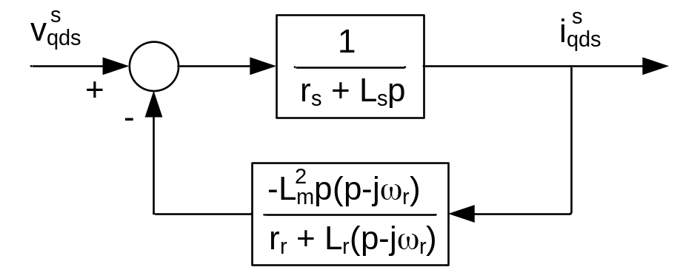
or
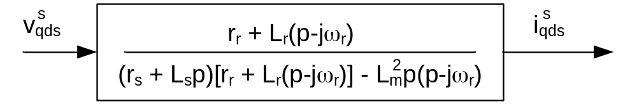
Complex, Stator Referred Block Diagram for a Squirrel Cage Induction Motor

Rotation to a General Reference Frame

→

General Reference Frame Referred, Complex Variable Equations:

e ^{- jθ} v = r_{s} e ^{- jθ} i + L_{s} e ^{- jθ} p i + L_{m} e ^{- jθ} p i
Note: p[e ^{- jθ} i] = e ^{- jθ} p i + i (-j ω) e ^{- jθ}
→ e ^{- jθ} p i = p[e ^{- jθ} i] + j ω e ^{- jθ} i = (p + j ω) e ^{- jθ} i

if ω = 0 & θ = 0 → Stator Reference Frame

if ω = ω_{r} & θ = θ_{r} → Rotor Reference Frame

if ω = ω_{e} & θ = θ_{e0} → Synchronous Reference Frame

Inverse abc – dq Transformation:

Transformation:

v = [v_{as} + a v_{bs} + a² v_{cs}]

v_{0s} = [v_{as} + v_{bs} + v_{cs}]

if v_{as} + v_{bs} + v_{cs} = 0 = v_{0s}

recall:
a = e^{+j120o} = + j
a² = e^{+j240o} = - j

v =

=
= -v_{as}

= = v_{as} - j

therefore

v = v_{as}

v = = -

Inverse Transformation:

v =

=

= v_{as} - v_{0s} + j (v_{bs} - v_{cs})
v_{as} = Re [v] + v_{0s}

v_{bs} = Re [a² v] + v_{0s}

v_{cs} = Re [a v] + v_{0s}

Summary

Forward Transformation:

=

Inverse Transformation:

=

Stationary to Rotationg | Rotating to Stationary
f  = | f  =

Power Flow in 3φ Machines:

P_{sabc} = v_{as} i_{as} + v_{bs} i_{bs} + v_{cs} i_{cs} ← Stator Power

P_{rabc} = v_{ar} i_{ar} + v_{br} i_{br} + v_{cr} i_{cr} ← Rotor Power

P_{sqd} = v i + v i = Re [v i]

= Re = Re

= (v_{as} i_{as} + v_{bs} i_{bs} + v_{cs} i_{cs}) + Re

a = + j =

=

P_{sqd} = [v_{as} i_{as} + v_{bs} i_{bs} + v_{cs} i_{cs}] - (3v_{0s}) (3i_{0s})

Stator Power

Note: P_{sqd} is not equal to P_{sabc} because of choice of as a scaling factor during transformation. For a scaling of , this power in abc = qd (called the “power invariant transformation”).

P_{sabc} = Re [v i] + 3 v_{0s} i_{0s} (can ususually neglect zero sequence terms)

= Re [() ()*] + 3 v_{0s} i_{0s} = [v i] + 3 v_{0s} i_{0s}

Note: Reference Frame Invariant

P_{intotal} = Re [v i + v i] + 3 v_{0s} i_{0s} + 3 v_{0r} i_{0r}

Assuming no zero sequence components:

P_{intotal} = Re {[] i +
v

[] i}
v

L_{m} + L_{ls}

= Re {r_{s} |i|² + L_{s} p |i|² + j ω L_{s} |i|² + L_{m} p i i + j ω L_{m} i i +
r_{r} |i|² + L_{r} p |i|² + j (ω - ω_{r}) L_{r} |i|² + L_{m} p i i + j (ω - ω_{r}) L_{m} i i}

L_{m} + L_{lr}

= Re {r_{s} |i|² + r_{r} |i|² + L_{ls} p |i|² + L_{lr} p |i|² + L_{m} p |i + i|² +
j ω L_{s} |i|² + j (ω - ω_{r}) L_{r} |i|² + j ω L_{m} i i + j (ω - ω_{r}) L_{m} i i}

= (r_{s} |i|² + r_{r} |i|²) + p (L_{ls} |i|² + L_{lr} |i|² + L_{m} |i + i|²) +
0
Re {j ω L_{s} |i|² + j (ω - ω_{r}) L_{r} |i|² + j ω L_{m} i i + j (ω - ω_{r}) L_{m} i i}
0
Note: i i = [i i]*
so imaginary parts are negated

Therefore:

P_{intotal} = (r_{s} |i|² + r_{r} |i|²) + p (L_{ls} |i|² + L_{lr} |i|² + L_{m} |i + i|²) +
power lost in conductors
time rate of change of stored field energy

Re {j ω_{r} L_{m} i i}

electro-mechanical energy conversion conductors

P_{em} = Re {j ω_{r} L_{m} i i}

or

In scalar form:

recall: ω_{r} = ω_{rm}

← Electromagnetic Torque

Stator Flux Linkage is related to stator & rotor currents by
l = L_{s} i + L_{m} i

The torque in terms of stator currents and flux linkage can be expressed as:

no imaginary component

The torque can be viewed as the interaction of rotor flux and stator current. This is extremely useful for torque control, known as field oriented control.

l = L_{r} i + L_{m} i → i = l - i

Equation Summary for Simulation:

The following is a listing of state equations which can be used in simulating an AC machine:

p λ = v – r_{s} i

p λ = v – r_{s} i

p λ = v – r_{r} i + ω_{r} λ

p λ = v – r_{r} i - ω_{r} λ

T_{e} = L_{m} (i i - i i)

where
λ = L_{s} i + L_{m} i

λ = L_{s} i + L_{m} i

λ = L_{r} i + L_{m} i

λ = L_{r} i + L_{m} i

so
σ = 1 – (coupling factor)
i =

i =

i = λ - λ

i = λ - λ

The torque can be viewed as the interaction of rotor flux and stator current. This is extremely useful for torque control, know as field oriented control.

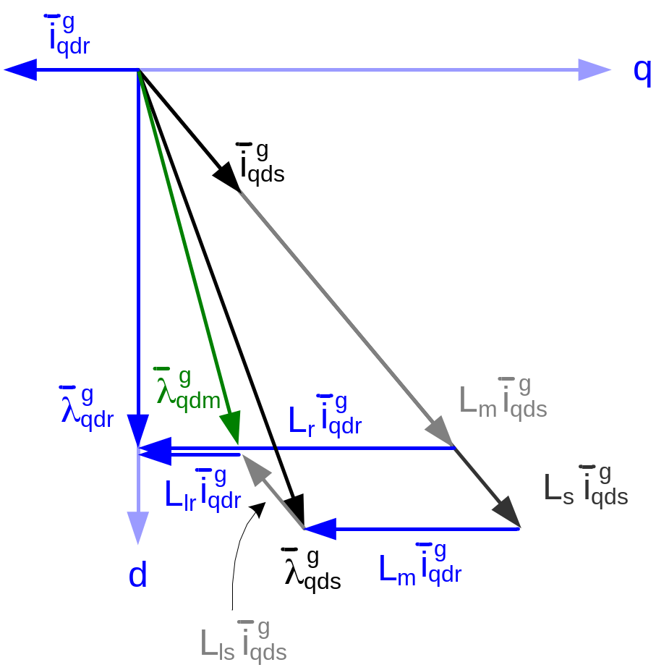
Vector Axis Representation of Complex Vector Equations (d-axis Aligned with Rotor Flux)

Physical interpretation of flux in an AC machine:

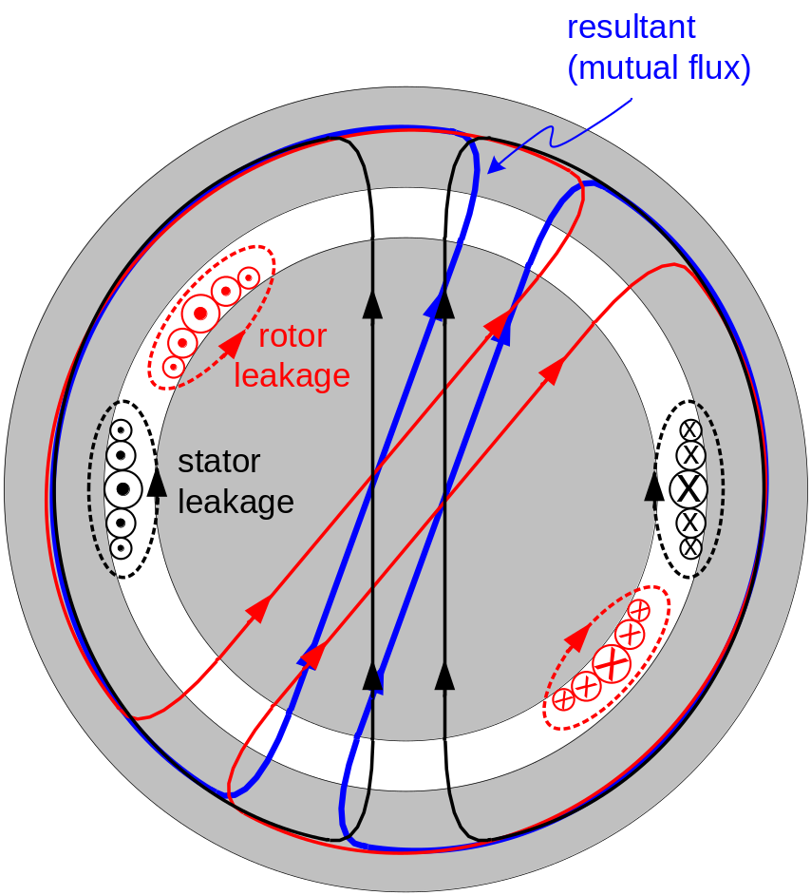
Physical Interpretation of Flux in an AC Machine

d,q,0 Theory Applied to Salient Pole Machines:

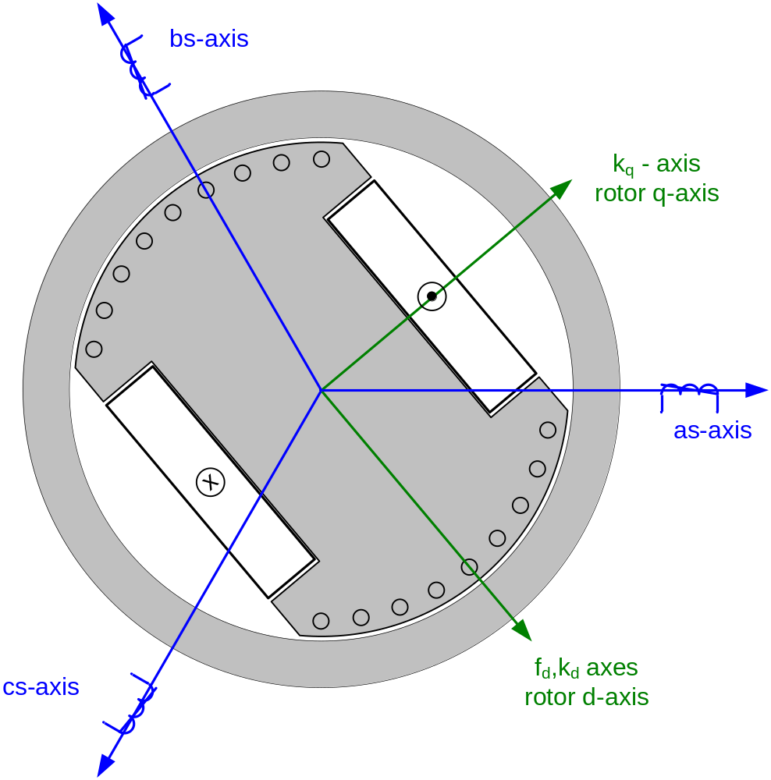
Salient Pole Wound Field Synchronous Machine

Self inductance is a function of rotor position. Neglecting higher order harmonics:

L_{as,as} = L_{ls} + L_{0s} – L_{2s} cos(2θ_{r})

L_{0s} = μ_{o} r l Ns

L_{2s} = μ_{o} r l Ns

L_{bs,bs} = L_{ls} + L_{0s} – L_{2s} cos(2θ_{r} + 120º)

L_{cs,cs} = L_{ls} + L_{0s} – L_{2s} cos(2θ_{r} – 120º)

Mutual Inductances:

L_{as,bs} = L_{bs,as} = L_{0s} – L_{2s} cos(2θ_{r} – 120º)

L_{as,cs} = L_{cs,as} = L_{0s} – L_{2s} cos(2θ_{r} + 120º)

L_{bs,cs} = L_{cs,bs} = L_{0s} – L_{2s} cos(2θ_{r})

The inductances cooresponding to the flux linking the field winding with the three stator phases are:

L_{as,fd} = L_{fd,as} = L_{sfd} cos(θ_{r})

L_{bs,fd} = L_{fd,bs} = L_{sfd} cos(θ_{r} – 120º)

L_{cs,fd} = L_{fd,cs} = L_{sfd} cos(θ_{r} + 120º)

L_{sfd} = μ_{o} r l N_{s} N_{r}

The inductances cooresponding to the flux linking the d-axis damper winding with the three stator phases are:

L_{as,kd} = L_{kd,as} = L_{skd} cos(θ_{r})

L_{bs,kd} = L_{kd,bs} = L_{skd} cos(θ_{r} – 120º)

L_{cs,kd} = L_{kd,cs} = L_{skd} cos(θ_{r} + 120º)

L_{skd} = μ_{o} r l N_{s} N_{kd}

The inductances cooresponding to the flux linking the q-axis damper winding with the three stator phases are:

L_{as,kq} = L_{kq,as} = –L_{skq} sin(θ_{r})

L_{bs,kq} = L_{kq,bs} = –L_{skq} sin(θ_{r} – 120º)

L_{cs,kq} = L_{kq,cs} = –L_{skq} sin(θ_{r} + 120º)

L_{skq} = μ_{o} r l N_{s} N_{kq}

Referring the stator variables to the rotor:

v = r_{s} i + (p + j ω)l or

v = r_{s} i + p λ + ω_{r} λ

v = r_{s} i + p λ – ω_{r} λ

v = r_{s} i + p λ

actual field voltage
actual currents, voltages, and flux linkages

v = r_{s} i + p λ
use scalar equations instead of complex equations due to lack of symmetry

v = r_{s} i + p λ

λ = L_{q} i + L_{mq} (i)

λ = L_{d} i + L_{md} (i + i)

λ = L_{kq} i + L_{mq} (i)

λ = L_{kd} i + L_{md} (i)

Salient Pole Machine Torque

T_{e} = Im{i l } = [λ i - λ i]

= [L_{md} i (i + i) + -L_{mq} i (i) + (L_{md} – L_{mq}) i i]
BLI torque (excitation or reaction torque)
Damping (induction motor) torque
Reluctance torque

Extension of d,q,0 theory to PM Machines:

This is a special case of salient pole machines

Λ_{mf} = L_{md} i

Park’s Equations for a PM Machine with a starting cage are:

v = r_{s} i + p λ + ω λ

v = r_{s} i + p λ – ω λ

v = r_{s} i + p λ

v = r_{s} i + p λ

where

λ = L_{ls} i + L_{mq} (i + i)

λ = L_{ls} i + L_{md} (i + i) + Λ_{mf}

λ = L_{lkq} i + L_{mq} (i + i)

λ = L_{lkd} i + L_{md} (i + i) + Λ_{mf}

Steady State dq Model of Torque Controlled Synchronous Machine:
Constraints:
1) Constant Amplitude and Phase of i

i = I_{qs} , i = I_{ds}

2) Constant Rotor Flux

i = 0 , i = 0 (no damper currents)

3) Constant Rotor Field Current

i = I_{f}
0
0
T_{e} = [λ i - λ i] = [(L_{md} I_{f} + L_{md} i + L_{ds} I_{ds}) I_{qs} – (L_{mq} i + L_{qs} I_{qs}) I_{ds}]
λ_{r}

= [L_{md} I_{f} I_{qs} – (L_{ds} – L_{qs}) I_{qs} I_{ds}]
BLI torque
Reluctance torque

v = r_{s} I_{qs} + ω_{r} λ  = r_{s} I_{qs} + ω_{r} [L_{md} I_{f} + L_{ds} I_{ds}]  v = r_{s} I_{qs} – ω_{r} λ  = r_{s} I_{qs} – ω_{r} L_{qs} I_{qs} | 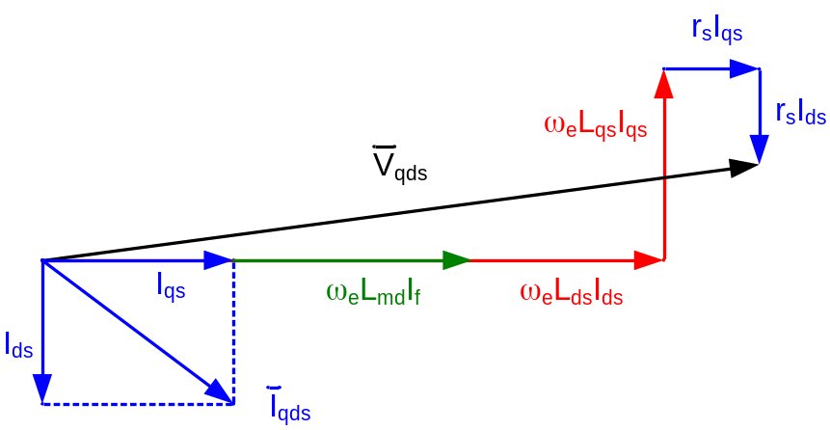
 | Vector Diagram of Steady State Operation of Synch. Motor

Steady State Induction Machine Field Orientation Using dq Model:
Constraints:
1) Independent control of i

i = I_{qs} , i = I_{ds}

2) Orient Reference Frame to Rotor Flux such that i is in direction of Rotor Flux

Rotor Flux Equation:

l = L_{m} i + L_{r} i

λ = L_{m} i + L_{r} i = 0 ← all flux aligned with d-axis

therefore

λ = L_{m} i + L_{r} i = L_{m} I_{ds} + L_{r} I_{dr} ← steady state

Rotor Voltage Equations:
[p + j(ω_{e} – ω_{r})] l + r_{r} i = 0

j(ω_{e} – ω_{r}) l + r_{r} I_{qdr} = 0 ← steady state

λ – j λ I_{qr} – j I_{dr}

(ω_{e} – ω_{r}) λ + r_{r} I_{qr} = 0

–(ω_{e} – ω_{r}) λ + r_{r} I_{dr} = 0 → I_{dr} = 0 (since λ = 0)

therefore

ω_{e} – ω_{r} = I_{qr} = =

ω_{e} – ω_{r} = ← slip relationship for field orientation
rotor time constant

0
T_{e} = Im{i l } = [λ i - λ i] = I_{ds} I_{qs}
torque producing current
field
current

Stator Voltage Equation:
0 for steady state
v = r_{s} i + (p + j ω_{e})l

V_{qds} = r_{s} I_{qds} + j ω_{e} l ← steady state

l = L_{s} I_{qds} + L_{m} I_{qdr}
eliminate I_{qdr}

l = L_{m} I_{qds} + L_{r} I_{qdr}

l = σ L_{s} I_{qds} + l σ = 1 – (coupling factor)

V_{qds} = (r_{s} + j ω_{e} σ L_{s}) I_{qds} + j ω_{e} l

I_{qr} is like the compensating winding in a DC machine | 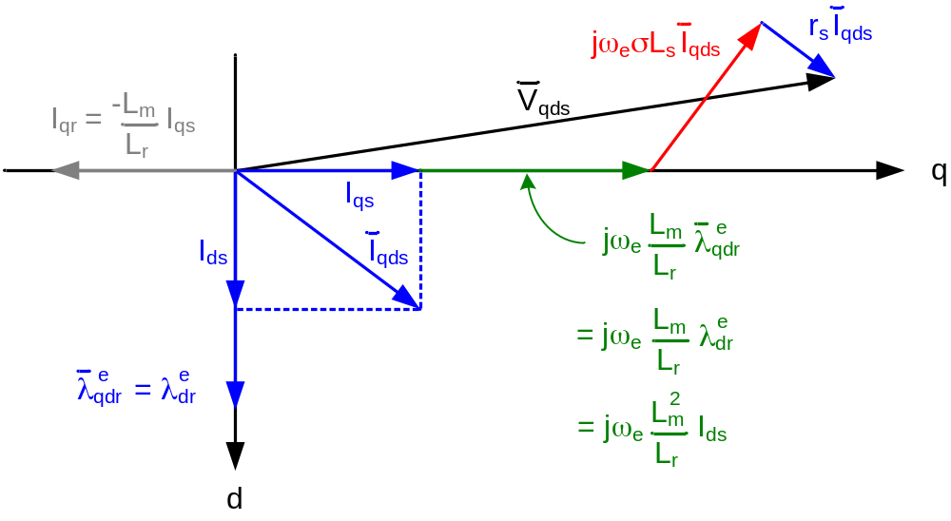
 | Vector Diagram of Steady State Operation of Induction Motor

Steady State Induction Machine Field Orientation:

λ = 0

1) I = I

2) I = 0

3) λ = L_{m} I

4) s ω_{e} = =

5) T_{e} = λ I

= I I

